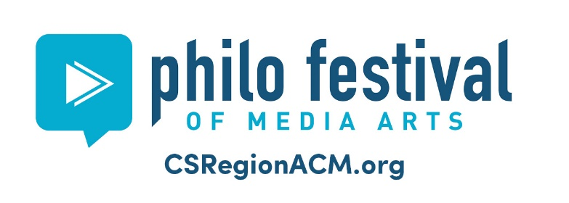

2021 Philo Excellence Awards

The Philo T. Farnsworth Excellence Award Winners will be announced during the Philo Festival of Media Arts Award virtual ceremony. Good luck to all the nominees below!
Excellence in Animation
What Is Campbell Media? Campbell Media Programming Coordinator Brady Wurtz

Excellence in Editing
Carmel Winter Games - The OMNI Centre for Public Media, Inc. City of Carmel, IN

Excellence in Directing
Philo Festival Awards Live, Access Fort Wayne, Otto Boschet, Norm Compton, John O'Rourke

Best Series Programs
Kids Want to Know: Abraham Lincoln, Access Fort Wayne, Kay Gregg, Emily Rapoza

Best in Show (Overall most amazing media of the year)
Martin Luther King Jr. Day Celebration, The OMNI Centre for Public Media, Inc. City of Carmel, IN

George Stoney Community Activism Award
A2ZERO: I Have A Vision, Tim Nagae, CTN Ann Arbor, City of Ann Arbor, MI

